Information Technology
Student's Name
Instructor
Information Technology
Many internet users may fail to know that once they see an online ad nit was placed there by auction for the specific slot. The slot is usually distributed to several advertisement bidders through a handful of an advertisement exchange, and it's often sold depending on the time that the page takes while loading. The whole process is generally automated and takes place within a short timeframe (Jack et al.47). One of the companies that are leading on driving that process has been using a software that is entirely based on its founders who helped in the planning of NASA missions of the traveling top the moons and mars. During the years 2004 and 2005, NASA funded some aerospace contractors who had a mission of sending astronauts to the moon and the mars which they later called the program as Office of Program Analysis and Evaluation.
The company based its previous plans and narrowed down the major decisions that had to be made and eventually created software that was based on the meta-language. A meta-language is one that that can be used in talking about language. It helped in articulating the mission that NASA had as well as developing different modules that were necessary for carrying human beings to a planetary body.
The Tiny Star Trackers have helped the spacecraft in finding their place. The Tiny Stars are not only being used for navigation purposes but also on the attitude control. Jason Mitchell explains that the mission for NASA needs to be flagged, which has not been enough to be miniaturized. There has been a recent development of the satellites being used where they have been a usage of much smaller satellites and still have become very cheap. The partnership between NASA and Adcole Maryland Aerospace that was based in Maryland came up with a decision on starting a Small Business Innovation Research (SBIR) contract.
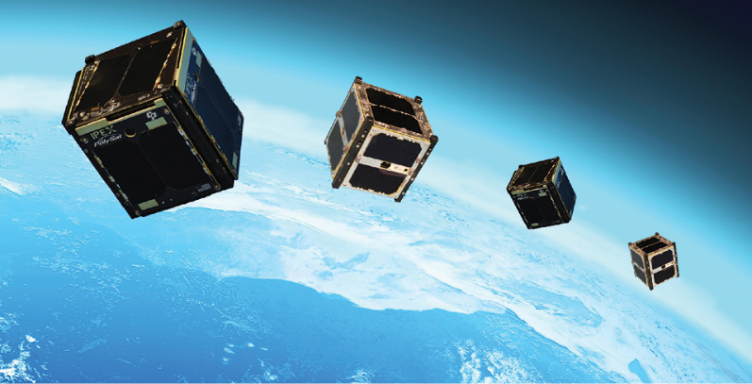
Some small satellites which are in other words called CubeSat and much cheap to build as well as launching them than the satellites which were previously used. To perform some scientific research, the engineers had to develop some new tools they are much small and that are cheap but as well as precise and powerful so that they can deliver excellent results.
“The instant combustion of the rockets is one of the key issues that make rocket science a bit challenging,” says Paul Gloyer. Instant combustion has been termed as one of the most significant risks that engineers face whenever they are designing engines (Schwalbe et al. 7). A project was developed that was funded by the Air Force, whose main objective was to come up with techniques that could be used in reducing engine combustion. Small Business Innovations Research supported the partnership and was one of the various awards that were issued to GTL by a variety of NASA Centers and other government agencies that helped in the development of the Universal Combustion Device Stability (UCDS), and it has been tool kiting over the last decade.
Just the same way that we use radio waves, the engineers have struggled to use the light beams in the space to transmit information since the advent of the laser back during the years the 1960s. No one had ever believed that mass communication by laser could be solved by former aviation (Dutta et al.67). There was a realization that four beta bytes were going to be created in every single day. This is a piece of information that could be transferred through the satellites, but it was not possible because the spacecraft could not bring back the information to the earth like the radio waves.
When the company was learning on the techniques that could be used in transferring the radio waves, it has scrapped its plans for tracking aircraft, and the technology was eventually licensed. Other companies have tried to create larger-scale satellite lacer systems of communication, but unfortunately, they all failed (Anthony et al. 36). Some of the obstacles that led to the above challenge include the snow as well as clouds. There are a variety of receivers on the ground, let alone the infrastructure that has been created to receive the users. The constellation of satellites is essential for interrupting communication.
The NASA engineers have been working hard towards improving the software that is responsible for simulating how air is flown around vehicles in flight since the years 1980s. The space shuttle posed a challenge over the above invention since the craft was designed to get attached to a huge external fuel tank that in turn carried some solid rocket boosters. The four different bodies reacted to each other in a more sophisticated way. Once they separated, there was a mixed reaction as the rocket started moving faster and became even challenging to simulate the air that was rushing around and between them.
Overflow became available through a software usage that was based on an agreement with Langley and was acquired widely all over the industry and the defense department. Overflow has been optimized to make it usable in most aircraft as well as the being applied in the military. Only the atmospheric speeds can be gagged to be beyond the speed of military jets which are believed to fly with a pace that is twice the speed of the sound. Some of the programs that users can obtain on the CFD include the FUN3D, which is also available from Langley.
Tiny Springs has dramatically helped in improving electronic reliability. Space exploration has come with many challenges where some of them include the connection issue in printing the circuit board and has resulted in a miniature solution. The Strickland and Hester's won the top prize for their innovation in the electronics category and proofed that they are potential for more innovations outside the aerospace. When licensed, it proved that they could develop some more products that could fit in the general product line. There were negotiations on the licensing of the company so that it could start producing and selling the micro-coil spring interconnectors on the Patent was granted although ultimately not granted to NASA.
The collaborative platform has been training students in simulation and modeling. A French man outfits the distribution depot with very minimal technology. From the beginning, the main idea was to capture data from the simulations and make it much portable to help in their preservations as well as being shared. The NASA teams that were mandated with the responsibility of operating simulations created massive datasets by use of some tools that ranged from supercomputers to the spreadsheets. DON and NASA have the responsibility of supplying the teams with high-level architecture software that is used for enabling the solar systems band, ensuring there is the positioning of the planetary bodies.
Work Cited
Anthony, John E. "Organic electronics: addressing challenges." Nature materials 13.8 (2014): 773.
Dutta, Soumitra, Thierry Geiger, and Bruno Lanvin. "The global information technology report 2015." World Economic Forum. Vol. 1. No. 1. 2015.
Marchewka, Jack T. Information technology project management: Providing measurable organizational value. John Wiley & Sons, 2016.
Schwalbe, Kathy. Information technology project management. Cengage Learning, 2015.

